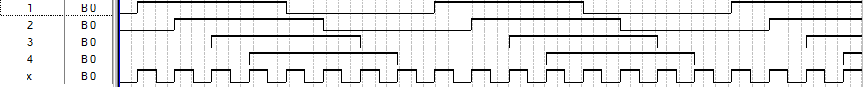

K=8
x | 1 | 2 | 3 | 4
0 | 0 | 0 | 0 | 0
1 | 1 | 0 | 0 | 0
0 | 1 | 0 | 0 | 0
1 | 1 | 1 | 0 | 0
0 | 1 | 1 | 0 | 0
1 | 1 | 1 | 1 | 0
0 | 1 | 1 | 1 | 0
1 | 1 | 1 | 1 | 1
0 | 1 | 1 | 1 | 1
1 | 0 | 1 | 1 | 1
0 | 0 | 1 | 1 | 1
1 | 0 | 0 | 1 | 1
0 | 0 | 0 | 0 | 1
1 | 0 | 0 | 0 | 0
0 | 0 | 0 | 0 | 0

